FRACTIONS, DECIMALS AND PERCENTAGES
Pearson Edexcel - Thursday 24 May 2018 - Paper 1 (Non-Calculator) Higher Tier
2.
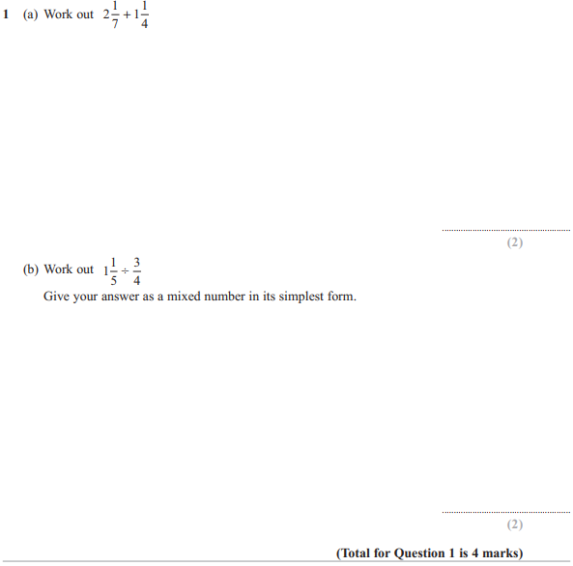

Pearson Edexcel - Monday 9 June 2014 - Paper 1 (Non-Calculator) Higher Tier
4.
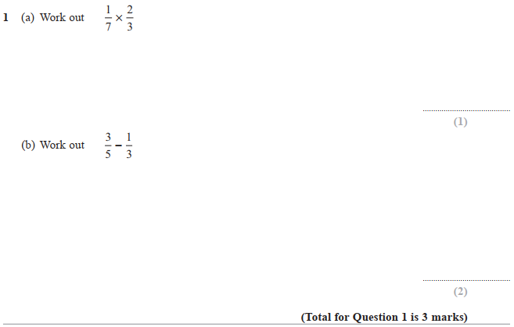

Pearson Edexcel - Wednesday 6 November 2013 - Paper 1 (Non-Calculator) Higher Tier
5.
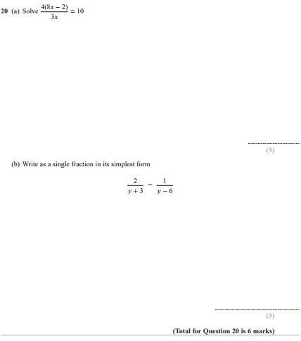

Pearson Edexcel - Monday 11 June 2012 - Paper 1 (Non-Calculator) Higher Tier
6.
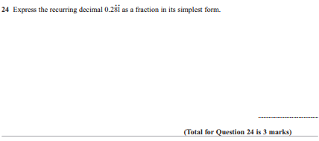

Pearson Edexcel - Wednesday 9 November 2011 - Paper 3 (Non-Calculator) Higher Tier
7.
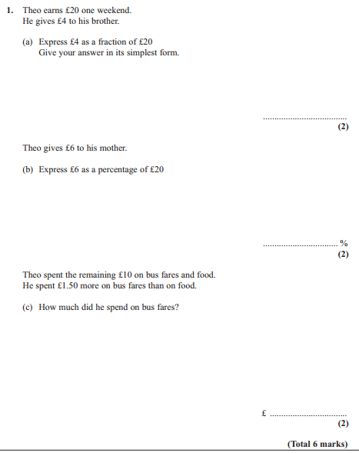

Pearson Edexcel - Friday 12 November 2010 - Paper 4 (Calculator) Higher Tier
8.
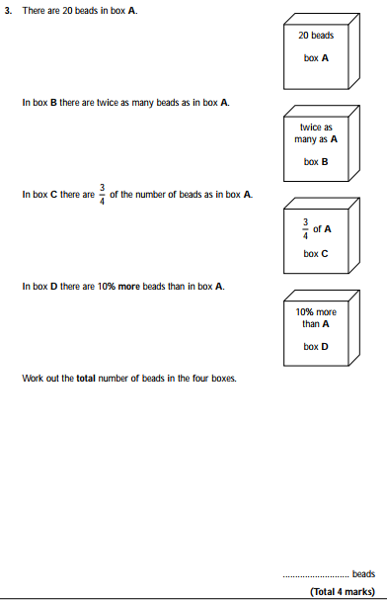

Pearson Edexcel - Thursday 5 November 2009 - Paper 3 (Non-Calculator) Higher Tier
9.
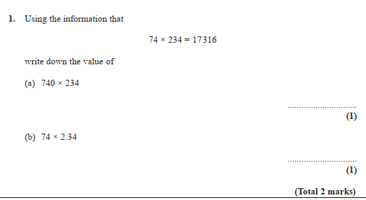

OCR GSCE – Thursday 7 November 2019 – Paper 5 (Non-Calculator) Higher Tier
10.
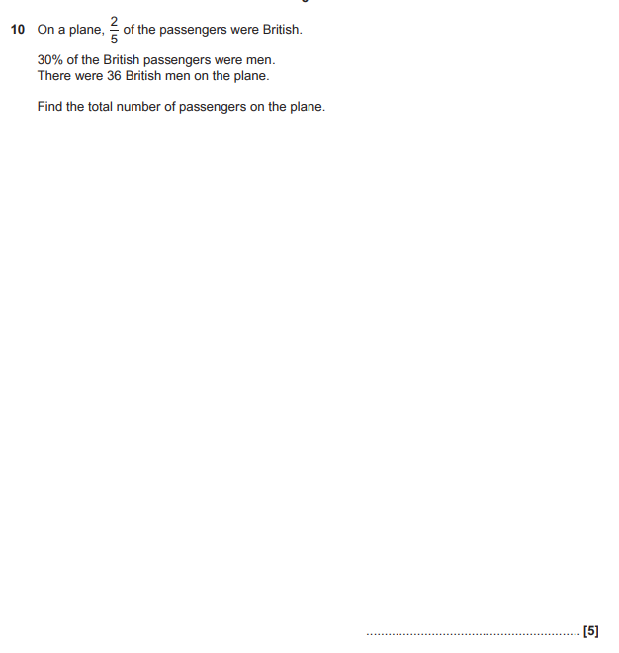

OCR GSCE – Thursday 7 November 2019 – Paper 5 (Non-Calculator) Higher Tier
11.
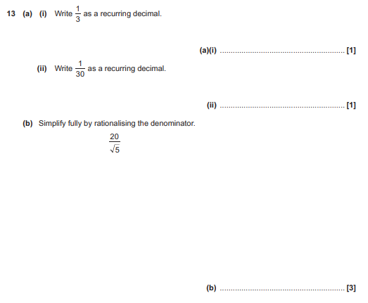

OCR GSCE – Thursday 6 June 2019 – Paper 5 (Non-Calculator) Higher Tier
12.
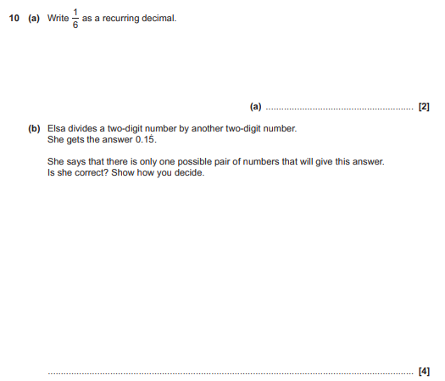

OCR GSCE – Monday 12 November 2018 – Paper 6 (Calculator) Higher Tier
13.
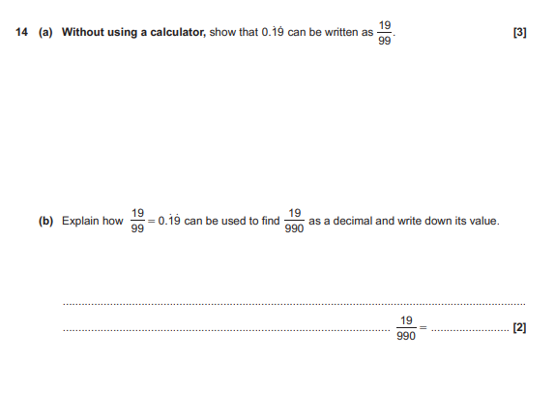

OCR GSCE – Thursday 7 June 2018 – Paper 5 (Non - Calculator) Higher Tier
14.
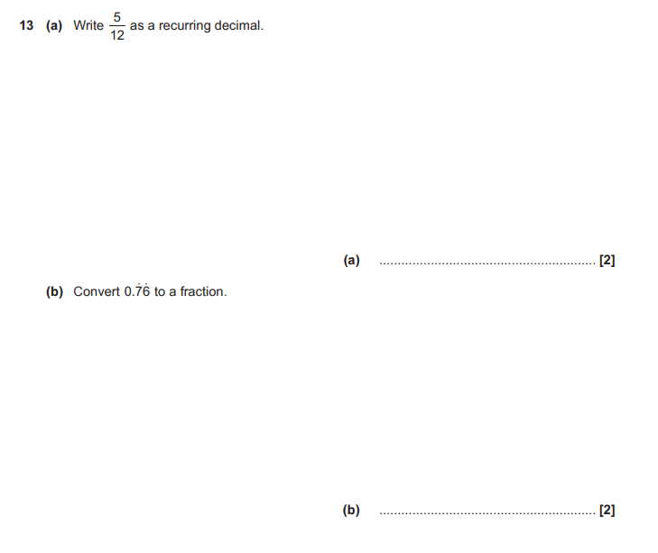

OCR GSCE – Tuesday 6 November 2017 – Paper 5 (Non - Calculator) Higher Tier
15.
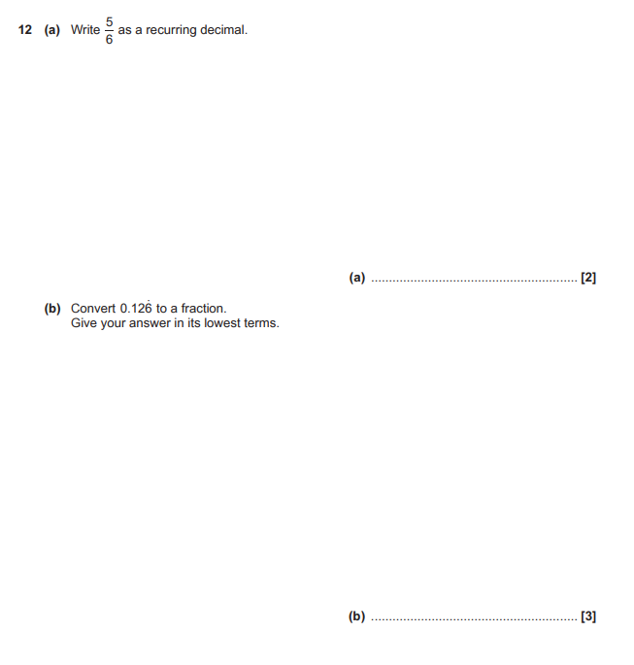

OCR GSCE – Thursday 8 June 2017 – Paper 5 (Non - Calculator) Higher Tier
16.
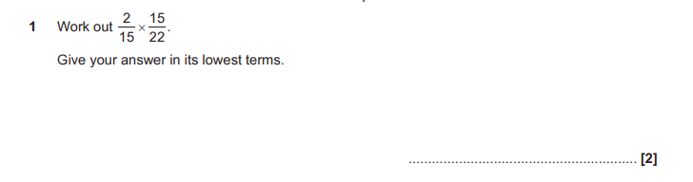
OCR GSCE – Thursday 8 June 2017 – Paper 5 (Non - Calculator) Higher Tier
17.
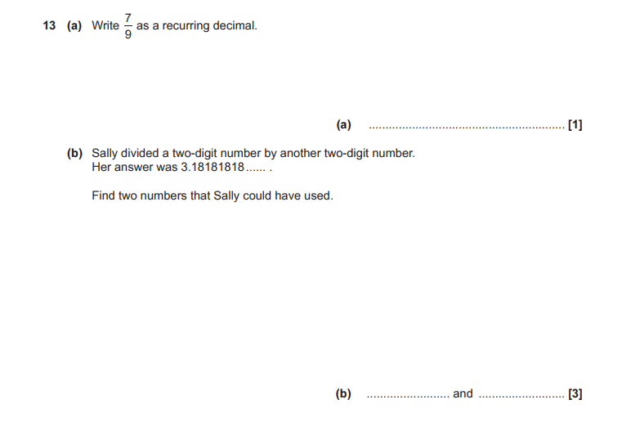

OCR GSCE – Sample Papers – Paper 6 (Calculator) Higher Tier
18.
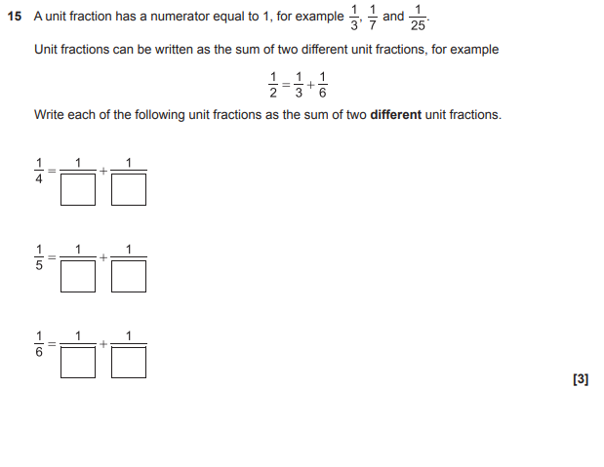

OCR GSCE – Tuesday 13 June 2017 – Paper 6 (Calculator) Higher Tier
19.
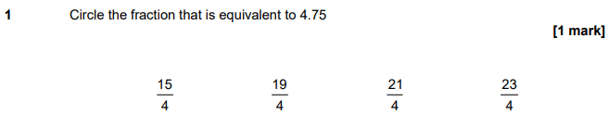
AQA GSCE – Tuesday 19 May 2020 – Paper 1 (Non - Calculator) Higher Tier
20.
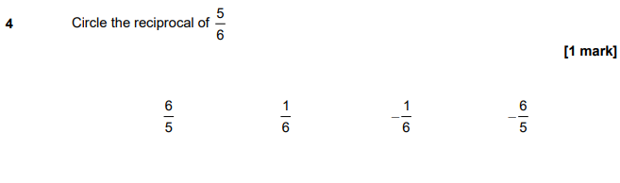
AQA GSCE – Tuesday 19 May 2020 – Paper 1 (Non - Calculator) Higher Tier
21.
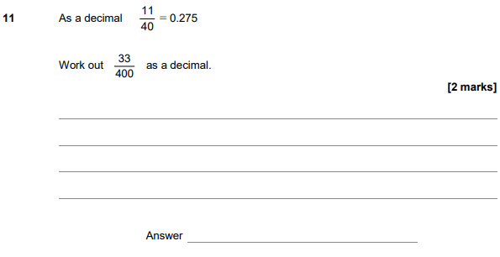
AQA GSCE – Tuesday 19 May 2020 – Paper 1 (Non - Calculator) Higher Tier
22.
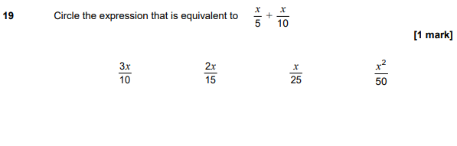

AQA GSCE – Thursday 8 June 2020 – Paper 3 (Calculator) Higher Tier
23.
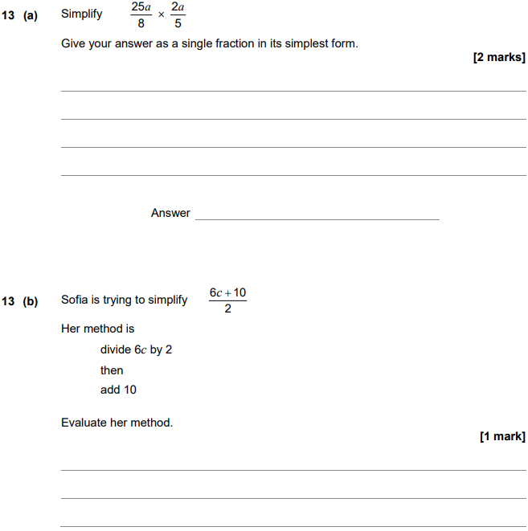

AQA GSCE – Tuesday 11 June 2019 – Paper 3 (Calculator) Higher Tier
24.
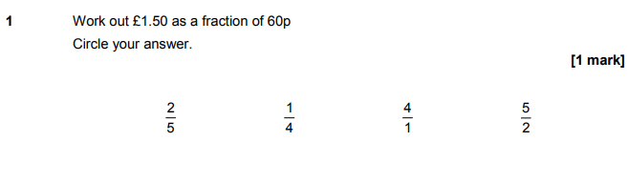
AQA GSCE – Tuesday 6 November 2018 – Paper 1 (Non - Calculator) Higher Tier
25.
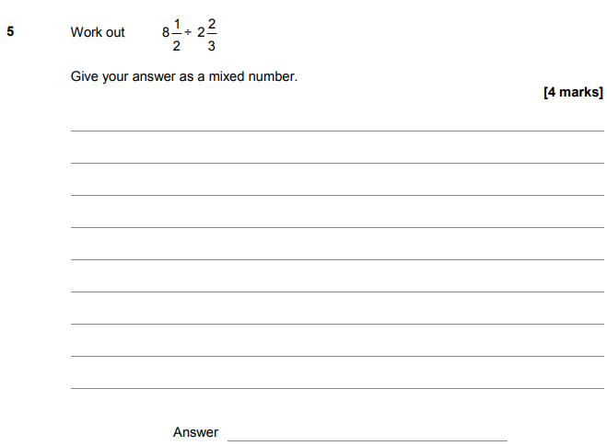

AQA GSCE – Monday 12 November 2018 – Paper 3 (Calculator) Higher Tier
26.
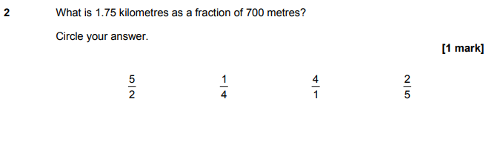
AQA GSCE – Monday 24 May 2018 – Paper 1 (Non - Calculator) Higher Tier
27.
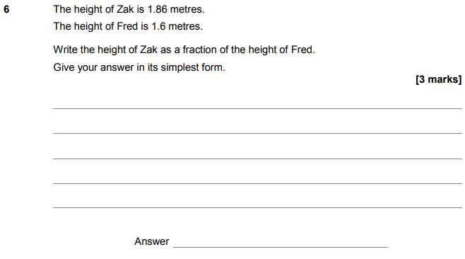

AQA GSCE – Monday 24 May 2018 – Paper 1 (Non - Calculator) Higher Tier
28.
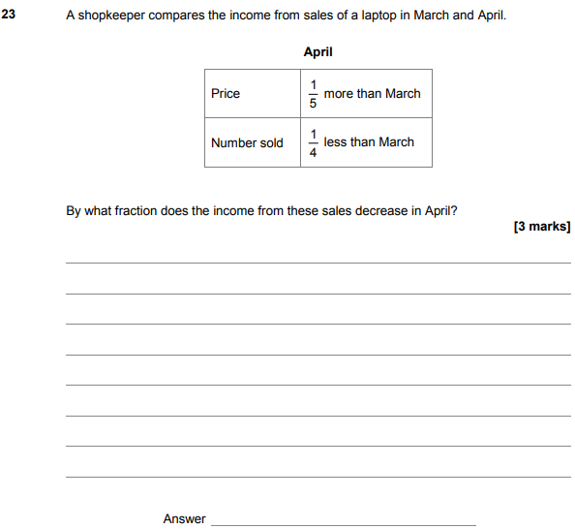

AQA GSCE – Tuesday 12 June 2018 – Paper 3 (Calculator) Higher Tier
29.
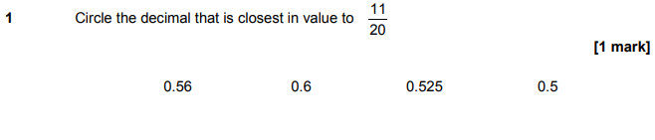
AQA GSCE – Thursday 6 November 2017 – Paper 2 (Calculator) Higher Tier
30.
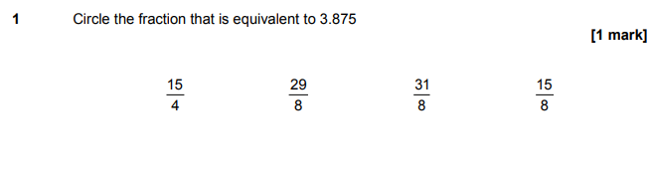
AQA GSCE – Wednesday 25 May 2017 – Paper 1 (Non - Calculator) Higher Tier
31.
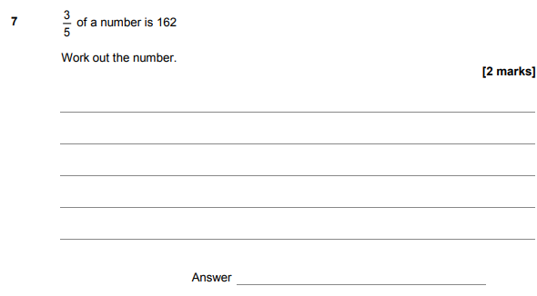

AQA GSCE – Wednesday 25 May 2017 – Paper 1 (Non - Calculator) Higher Tier
32.
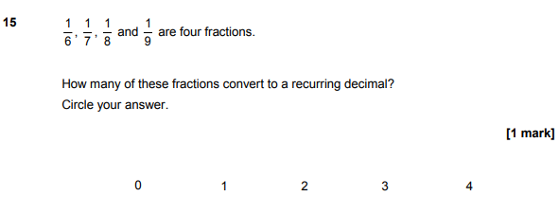
AQA GSCE – Thursday 8 June 2017 – Paper 2 (Calculator) Higher Tier
33.
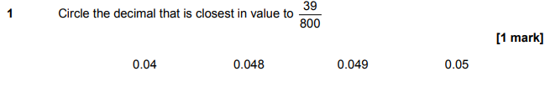
AQA GSCE – Sample Paper 1 (Non - Calculator) Higher Tier
34.
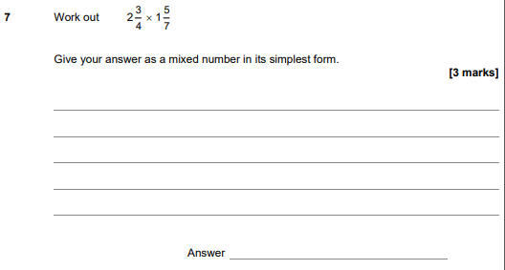

AQA GSCE – Sample Paper 1 (Non - Calculator) Higher Tier
35.
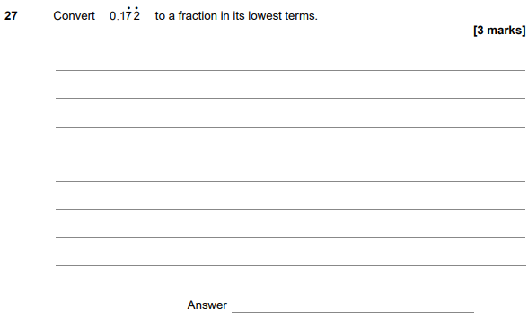
AQA GSCE – Sample Paper 2 (Calculator) Higher Tier
36.
